**Install Apache Server in UBUNTU using AWS Machine**

*NOTE: - Before we go to installation process, please make sure your instance will be connected in ubuntu server and after that get Linux terminal where we execute the installation process. That is given below*

**Steps 1:** Use Command sudo -i for root user active.

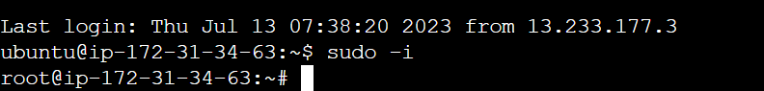

**Step 2:** Update Packages.



**Steps 3:** Install Apache2 Server.



**Steps 4:** Start Apache2 Server.



**Steps 5:** Check Apache2 Server is Active/Running or Not.



Here we show like this… its Active (running) status.

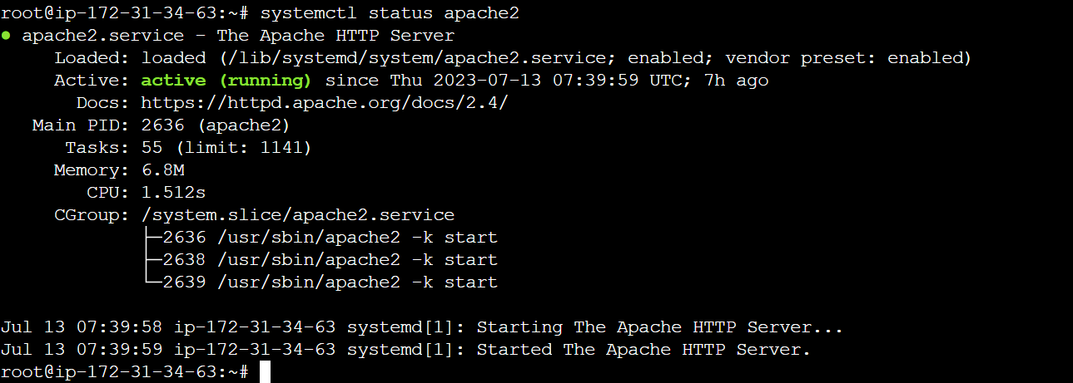

**NOW YOUR APACHE SERVER HAS BEEN INSTALLED OF VERSION APACHE2.**

**Steps 6:** Go to their path where we get index.html file.

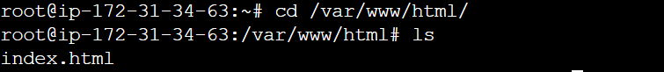

**Steps 7:** Remove all code from index.html file for creating a new code.



**Steps 8:** Edit index.html file for new code.



**Steps 9:** Write your own code.

Here is example, or anything write without using code.

We use html code for better result.

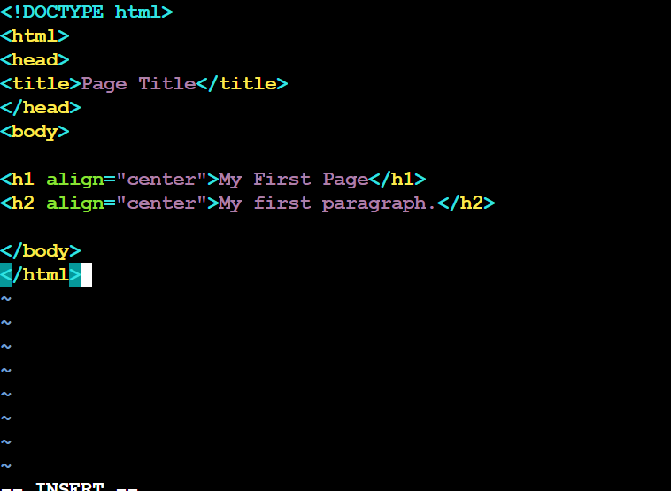

**Steps 10:** Save Code: Press{esc} and exit from editor Press {shift+: wq} then press enter key.

**Steps 11:** Again, go back to instance and copy Public IP Address and paste in new tab for see the output.

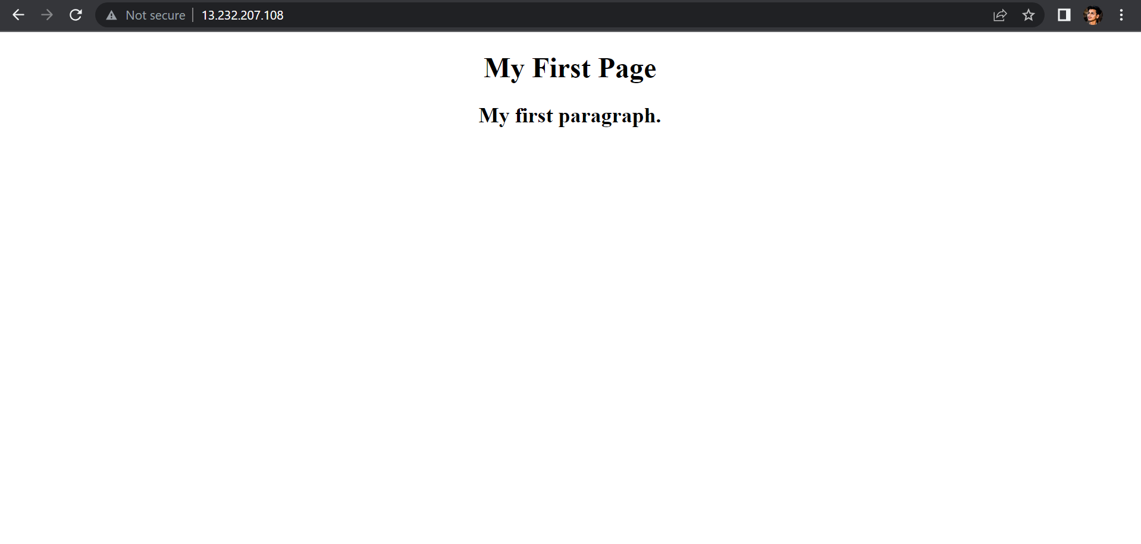

Here is My Output

**Thank You**